A listening Dinner with the host family
Listen to a conversation between three people: the German exchange student Paula, her host dad and host sister.

What is Paula unhappy about, or what does she find strange? Name six aspects. While listening, answer the questions in one to six words.

•
•
•
•
•
•

Listen to the conversation again. Tick () all the strategies that the Americans use during their dinner conversation.

pointing out cultural differences

saying that Paula is impolite

suggesting that it takes some time to understand the other culture

saying they are surprised that Paula likes it in the USA

pointing out negative things about German culture

explaining positive points about the USA

B mediation Explaining German traditions
You sent an American friend five photos with comments about German Christmas traditions. Immediately your friend asks you some questions about them.

Look at the photos, the comments and your friend’s questions. Answer your friend’s questions and explain these German traditions in English. Write at least two sentences about each tradition.

 |  | Suche |  |  |  |  |  | Startseite ▼
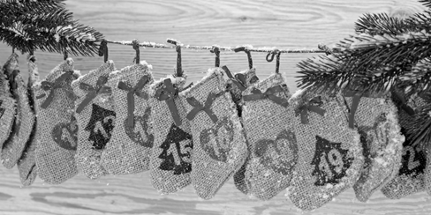
Mein Adventskalender
gepostet 1. Dezember kommentieren
What’s an “Adventskalender”? What do you do with it?
posted December 2 comment

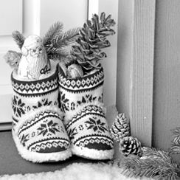
Nikolaustag am 6. Dezember
gepostet 6. Dezember kommentieren
Who is Nikolaus? What does he do?
posted December 6 comment comment


„Advent, Advent ein Lichtlein brennt“
gepostet 8. Dezember kommentieren
What is “Advent” and what are the candles for?
posted December 10 comment


Weihnachtsplätzchen!
gepostet 15. Dezember kommentieren
This looks yummy! Did you bake that? What is it made of?
posted December 15 comment


24. Dezember: Bescherung an Heiligabend
gepostet 24. Dezember kommentieren
Do you already get your presents on December 24? Can’t you wait until Christmas Day, the 25?
posted December 24 comment

C words Do this, don’t do that!
Complete the sentences with the correct adjectives. Use the words from the box with a negative prefix. Use each adjective only once. There are three more words than you need.

comfortable • expensive • fair • happy • legal •
necessary • polite • regular • responsible • usual

In the summer you shouldn’t leave your dog alone in the car.
Hot cars can be very (1) for pets.
It always makes me (2) when I
see poor animals stuck in cars like that. I think the government should make it (3) .



Dad won’t let me wear my new leather jacket to school because he thinks I’m
too (4) and I might lose it. And he said school isn’t
a fashion show, so cool clothes are completely (5) .
But I’m always careful with my stuff. I think he’s being really
(6) . And I like to wear nice clothes to school – that’s not so (7) for a 15-year-old girl.

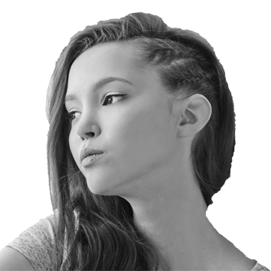

D passive voice The Golden Gate Bridge

Complete the text with the correct verb forms.
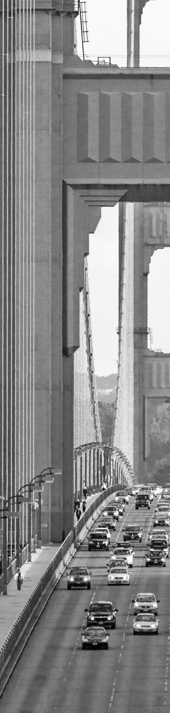
Today, the Golden Gate Bridge is seen (see) as one of the Wonders of the Modern World. It connects San Francisco to the north of California. It has six lanes¹ for cars and trucks and on every side pedestrians
(1) (protect) by sidewalks and railings.
The idea of a bridge (2) (bring up)
in 1916. It (3) (plan) in the 1920s by the American engineer Joseph Strauss and it
(4) (build) in the 1930s. Millions of dollars (5) (spend) on the construction until the bridge (6) (open) in 1937. From 1937 to 1970 pedestrians
(7) (ask) to pay money if they
wanted to cross the bridge, but today it is free. As the color for the bridge, international orange (8) (choose) so that everybody can see the bridge in all weather. Today it
(9) (paint) by about 40 workers who are only responsible for the bridge.
The Golden Gate Bridge is still very popular. The bridge and the area around it (10) (visit) by over 10 million people every year.
Fotos: Shutterstock (Joshua Tree National Park: milosk50)
¹ lane [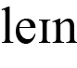] Fahrbahn

E passive with modals Sequoia National Park rules
Use the passive to complete the rules.

1 Sequoia National Park (can visit) 24 hours a day, 365 days a year.
2 Tours of Crystal Cave and other programs
(can reserve) from May till September.
3 Tents (may only set up) at the campsites in the park.
4 Prevent wildfire! Campfires
(must never leave) alone.
5 Food (should eat) in campsite and picnic areas.
6 After you have finished eating, the food
(have to put) away in closed boxes so that bears can’t smell it.
7 Animals (may not feed) by visitors.
8 Don’t just throw trash on the ground – keep the environment clean! Trash cans
(can find) everywhere in the park.

F writing A great time in California
 Do 1) or 2).

1) Charlie visited his friend Joshua in San Francisco. During his stay there he took photos and made some notes.
Write Charlie’s report for the school’s newspaper about his time in California. Use the photos and your own ideas. Think about:
– what Charlie and Joshua’s family saw.
– what they did.
– how Charlie liked it.
Make an outline, then write the report. Write at least 140 words. Use an extra piece of paper.

My host family
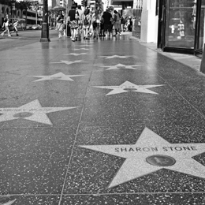
Walk of Fame – brilliant
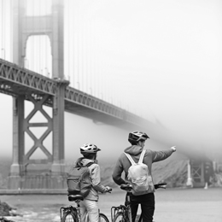
Bike tour to Golden Gate Bridge
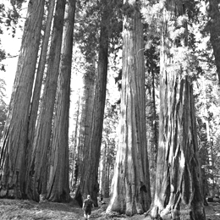
Awesome scenery in Sequoia National Park

+

2) Grace met her favourite star William Jones at the Starview Hotel in Los Angeles.
Write Grace’s report about her meeting for William’s fan page. Use the pictures and your own ideas.
Talk about:
– where they met.
– what they did.
– what they talked about.
– how Grace felt.
Make an outline, then write the report. Write at least 140 words. Use an extra piece of paper.



